[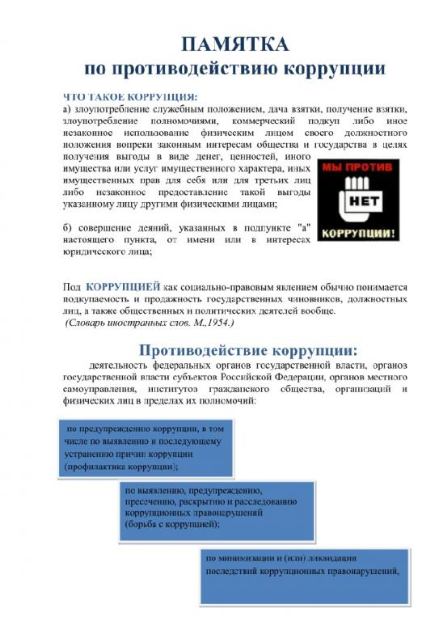](http://www.kovalevskoe-sp.ru/sites/kovalevskoe-sp.ru/files/imagecache/wysiwyg_imageupload_lightbox_preset/wysiwyg_imageupload/3/pamyatka_pro_protivod_kor_1.jpg)

[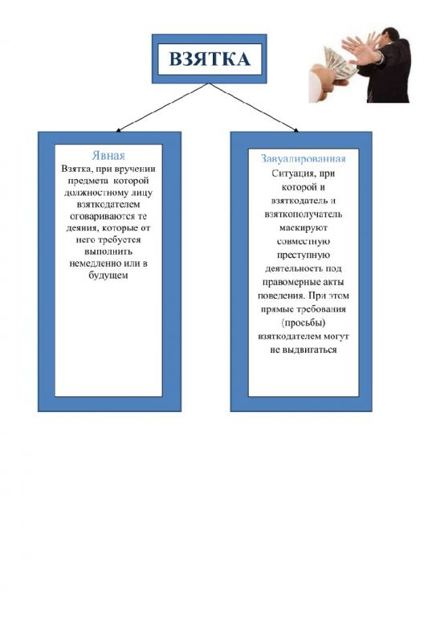](http://www.kovalevskoe-sp.ru/sites/kovalevskoe-sp.ru/files/imagecache/wysiwyg_imageupload_lightbox_preset/wysiwyg_imageupload/3/pamyatka_pro_protivod_kor_2.jpg)

[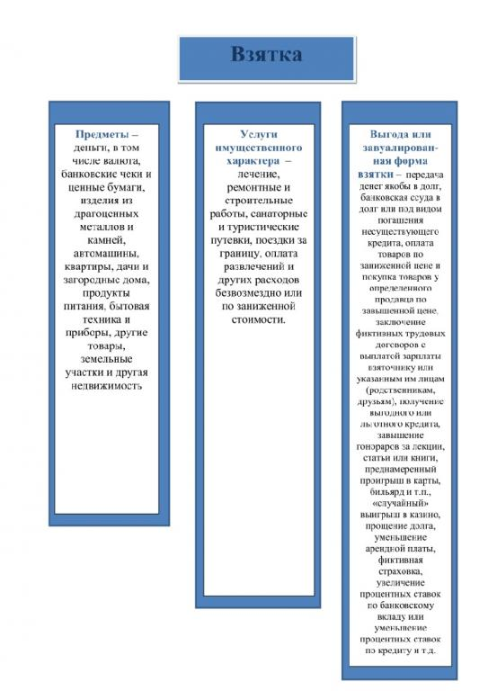](http://www.kovalevskoe-sp.ru/sites/kovalevskoe-sp.ru/files/imagecache/wysiwyg_imageupload_lightbox_preset/wysiwyg_imageupload/3/pamyatka_pro_protivod_kor_3.jpg)

[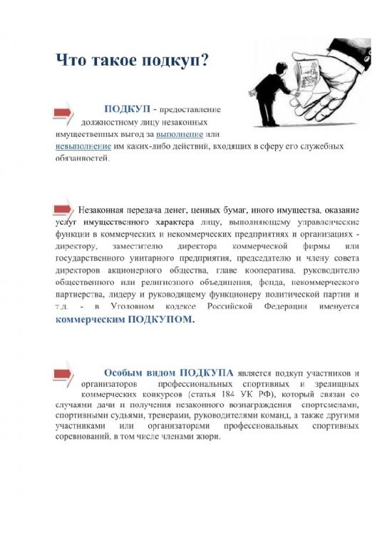](http://www.kovalevskoe-sp.ru/sites/kovalevskoe-sp.ru/files/imagecache/wysiwyg_imageupload_lightbox_preset/wysiwyg_imageupload/3/pamyatka_pro_protivod_kor_4.jpg)

[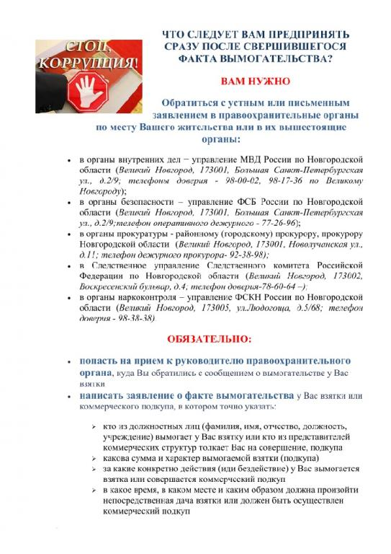](http://www.kovalevskoe-sp.ru/sites/kovalevskoe-sp.ru/files/imagecache/wysiwyg_imageupload_lightbox_preset/wysiwyg_imageupload/3/pamyatka_pro_protivod_kor_5.jpg)

[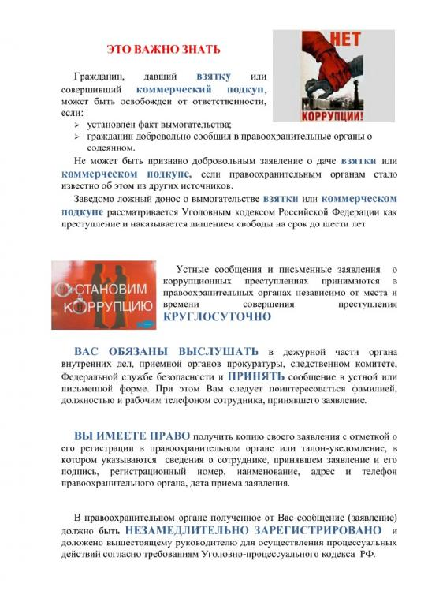](http://www.kovalevskoe-sp.ru/sites/kovalevskoe-sp.ru/files/imagecache/wysiwyg_imageupload_lightbox_preset/wysiwyg_imageupload/3/pamyatka_pro_protivod_kor_6.jpg)

[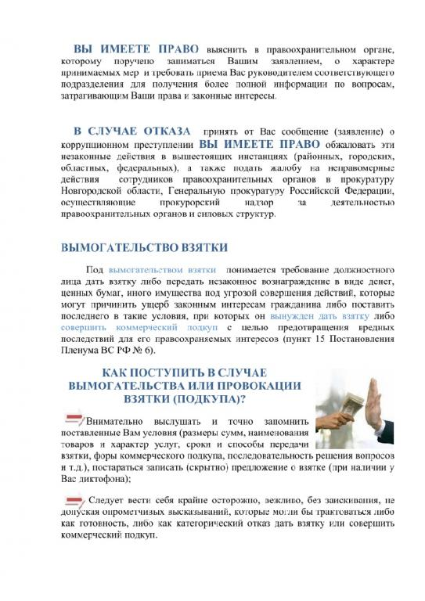](http://www.kovalevskoe-sp.ru/sites/kovalevskoe-sp.ru/files/imagecache/wysiwyg_imageupload_lightbox_preset/wysiwyg_imageupload/3/pamyatka_pro_protivod_kor_7.jpg)

[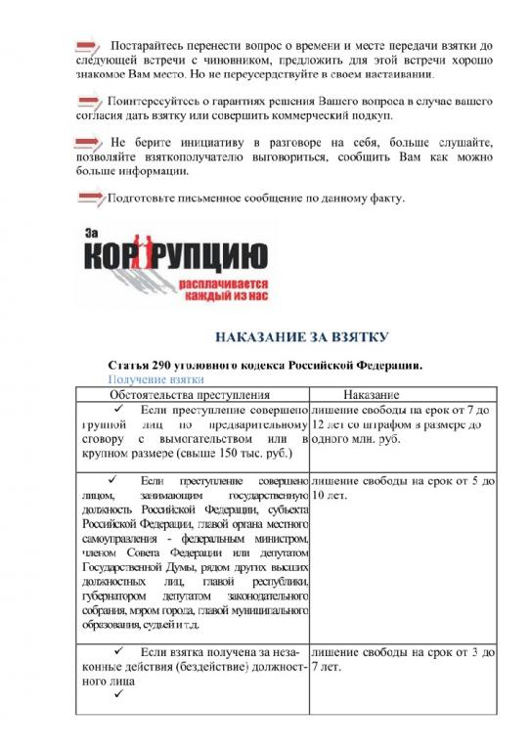](http://www.kovalevskoe-sp.ru/sites/kovalevskoe-sp.ru/files/imagecache/wysiwyg_imageupload_lightbox_preset/wysiwyg_imageupload/3/pamyatka_pro_protivod_kor_8.jpg)

[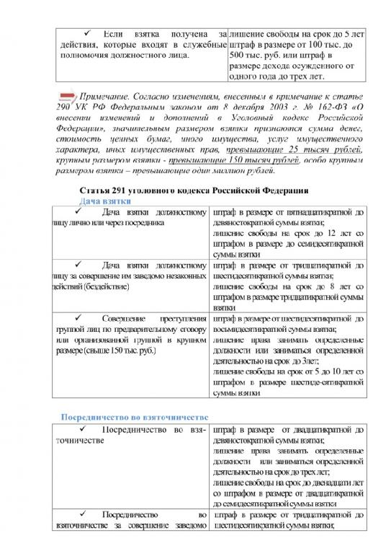](http://www.kovalevskoe-sp.ru/sites/kovalevskoe-sp.ru/files/imagecache/wysiwyg_imageupload_lightbox_preset/wysiwyg_imageupload/3/pamyatka_pro_protivod_kor_9.jpg)

[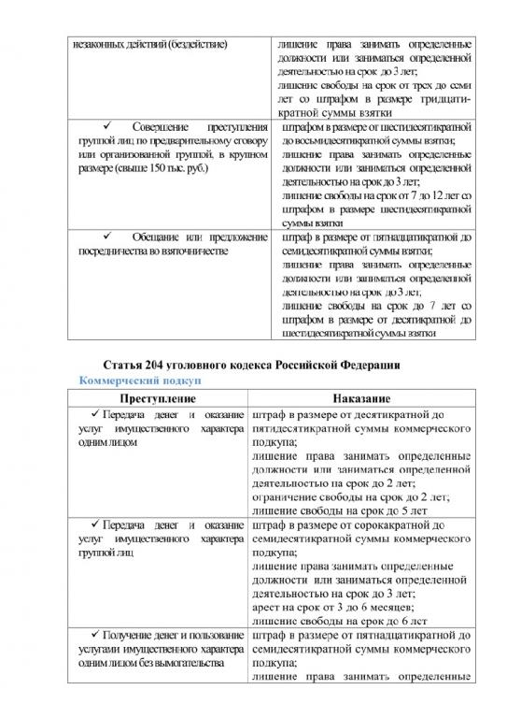](http://www.kovalevskoe-sp.ru/sites/kovalevskoe-sp.ru/files/imagecache/wysiwyg_imageupload_lightbox_preset/wysiwyg_imageupload/3/pamyatka_pro_protivod_kor_10.jpg)

[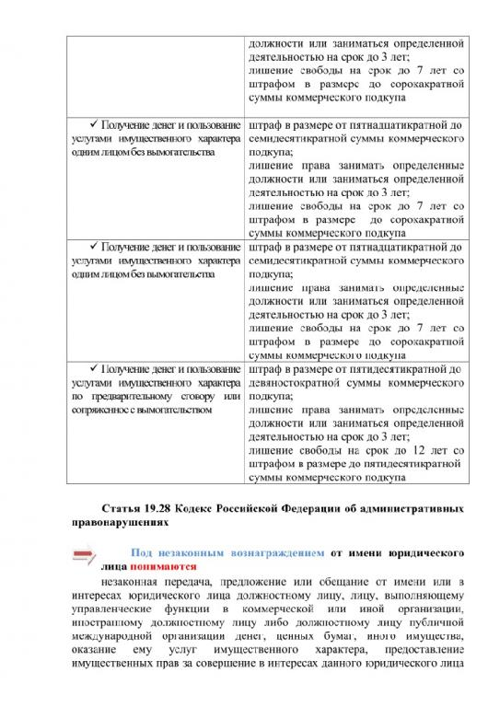](http://www.kovalevskoe-sp.ru/sites/kovalevskoe-sp.ru/files/imagecache/wysiwyg_imageupload_lightbox_preset/wysiwyg_imageupload/3/pamyatka_pro_protivod_kor_11.jpg)

[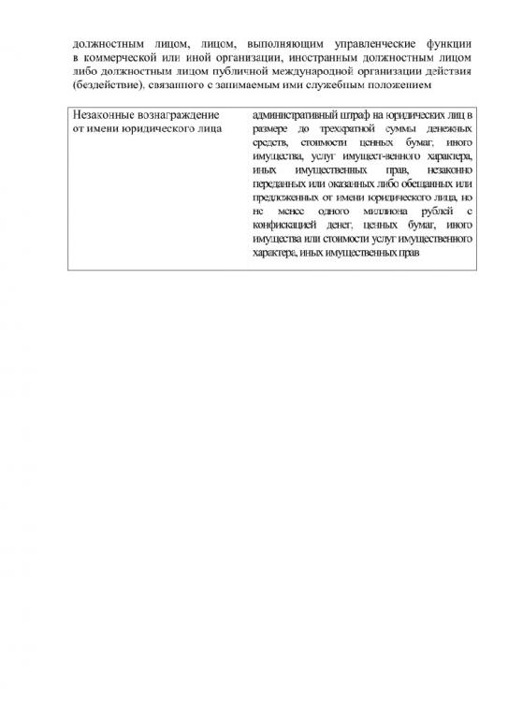](http://www.kovalevskoe-sp.ru/sites/kovalevskoe-sp.ru/files/imagecache/wysiwyg_imageupload_lightbox_preset/wysiwyg_imageupload/3/pamyatka_pro_protivod_kor_12.jpg)